**LINUX PROJECT**

**AGENDA :** THIS PROJECT IS SHOWING A DETAILES LOG OF CLIENT (USER) AUTH. DURING SSH LOGIN AND SERVER ADMINISTRATOR CAN EASILY FIND OUT VALID AND INVALID USER.

**TECHNOLOGY**:

* LINUX BASIC COMMAND
* IP AUTH.
* SSH CONF.
* MONITORING LOG

**DEVICE**:

* 2 COMPUTER

RADHAT LINUX AND KALI LINUX

**STEP1:-**

IN THIS WE CHECK THE CLIENT PC WILL PING

Ping (client pc ip)192.168.220.129

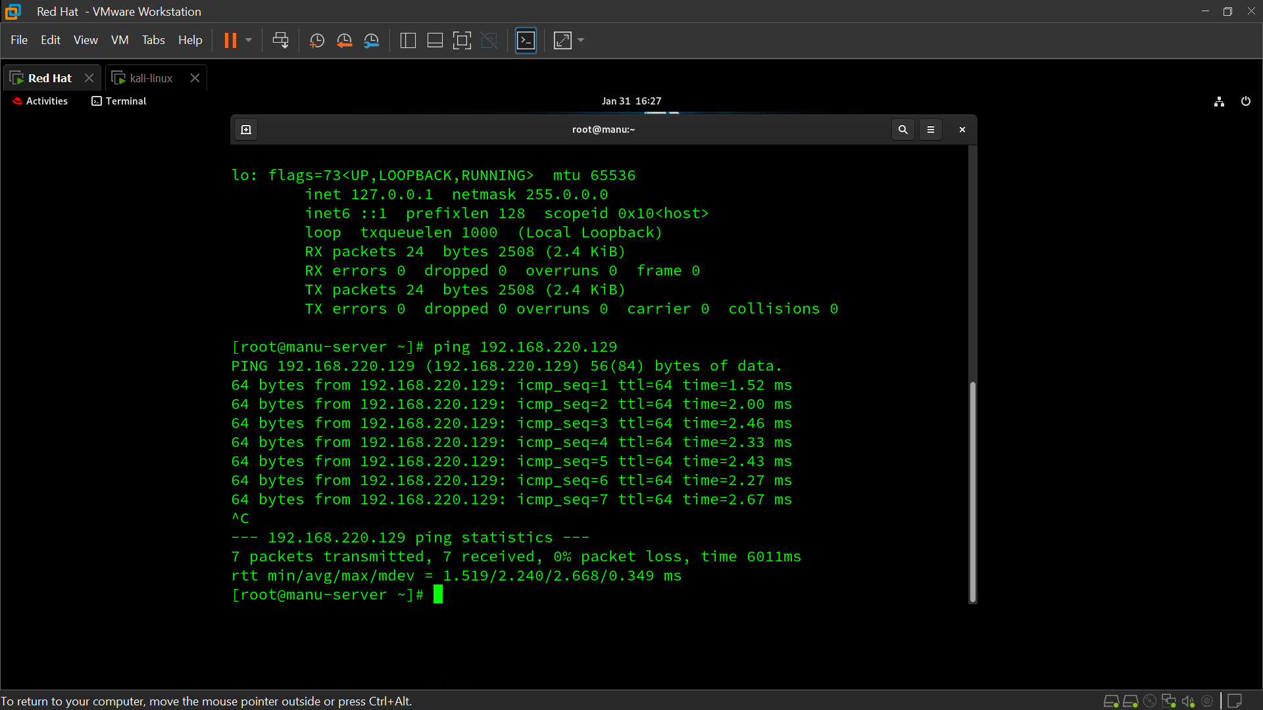

**STEP 2 :-**

WE CAN INSTALL OPENSSH IN SERVER PC ( yum install openssh* -y)

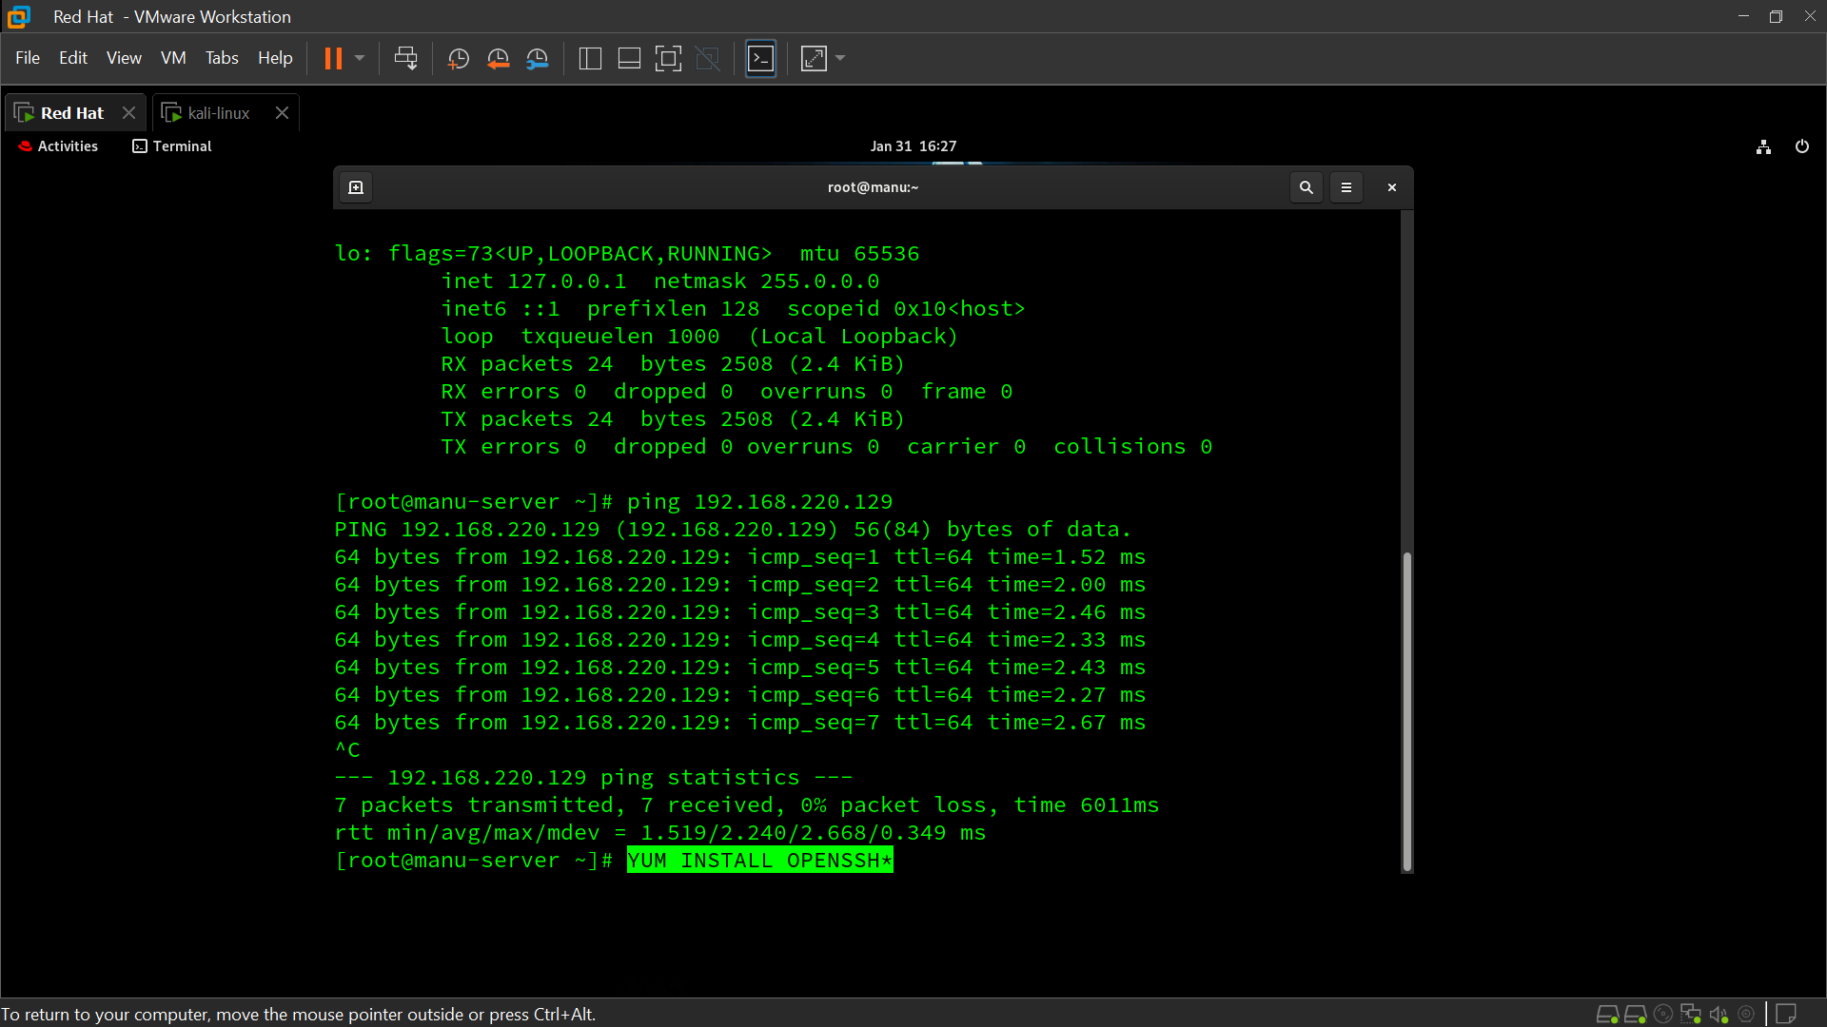

**STEP 3:-**

WE CAN INSTALL OPENSSH IN SERVER PC ( yum install ssh* -y)

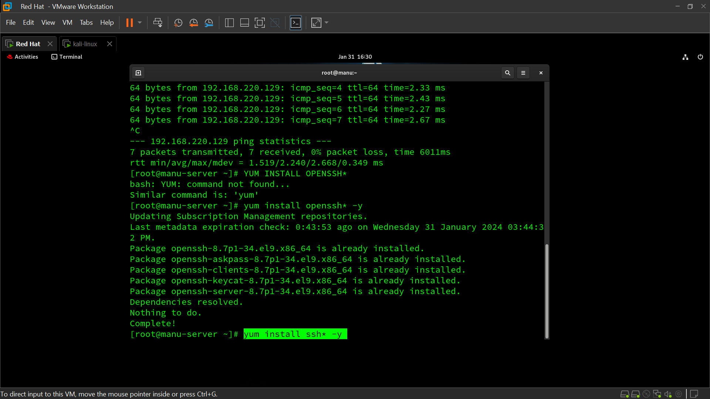

**STEP4:-**

GO TO THE FILE AND GAVE HIM PERMISSION

Vim /etc/ssh/sshd_config

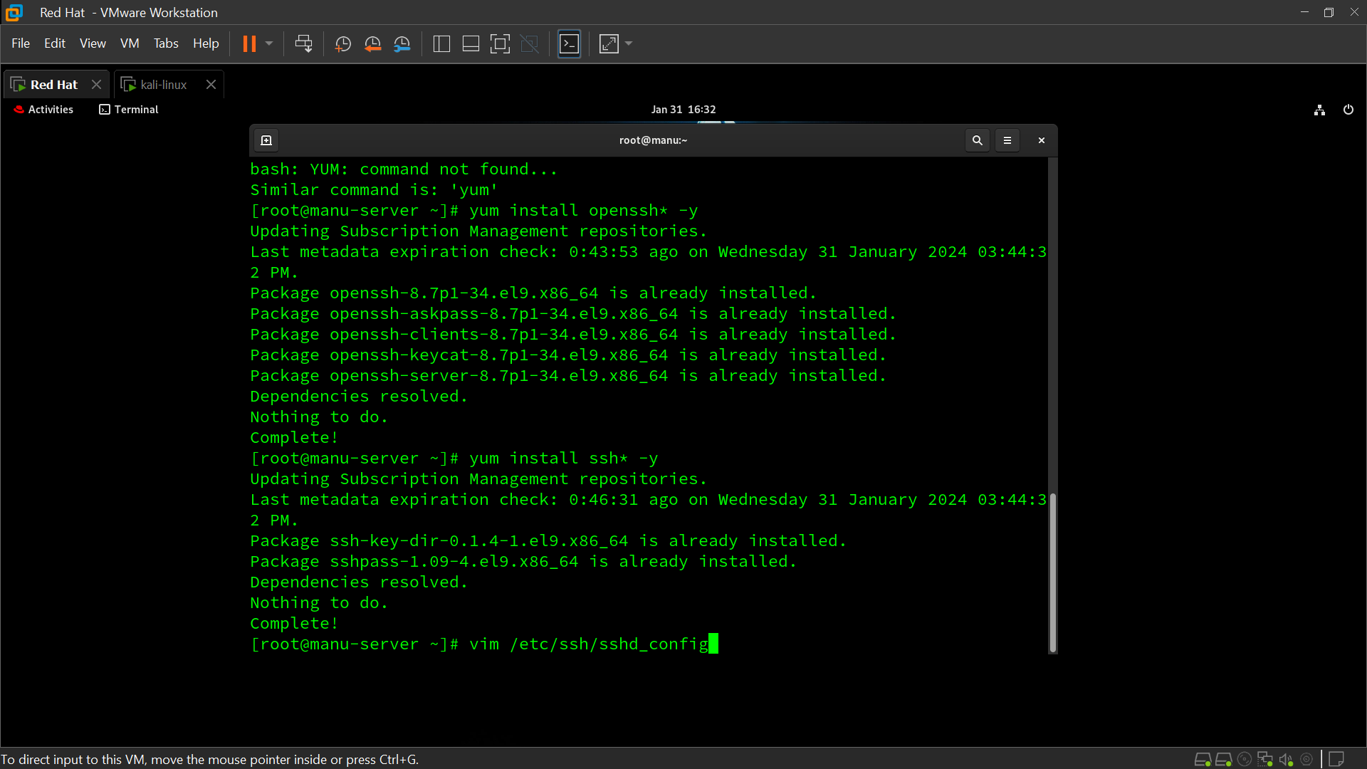

**STEP 5 :-**

GAVE HIM PERMISSION TO PERMITROOTLOGIN YES

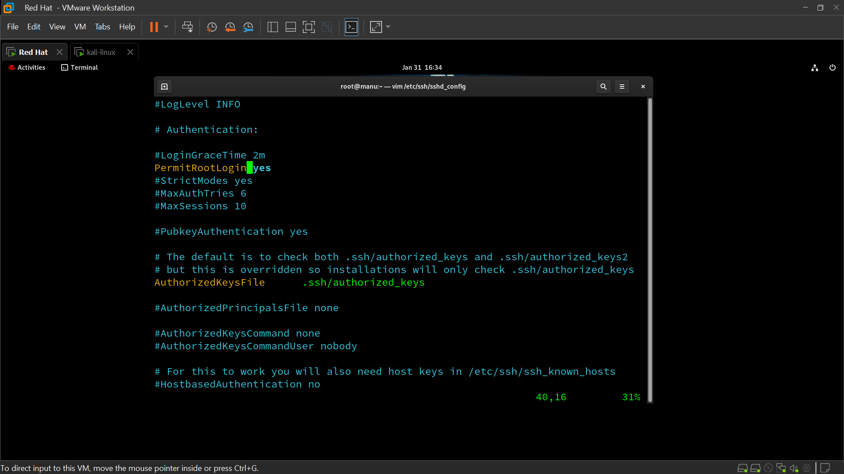

**STEP 6:-**

RESTART SSHD

Systemctl restart sshd

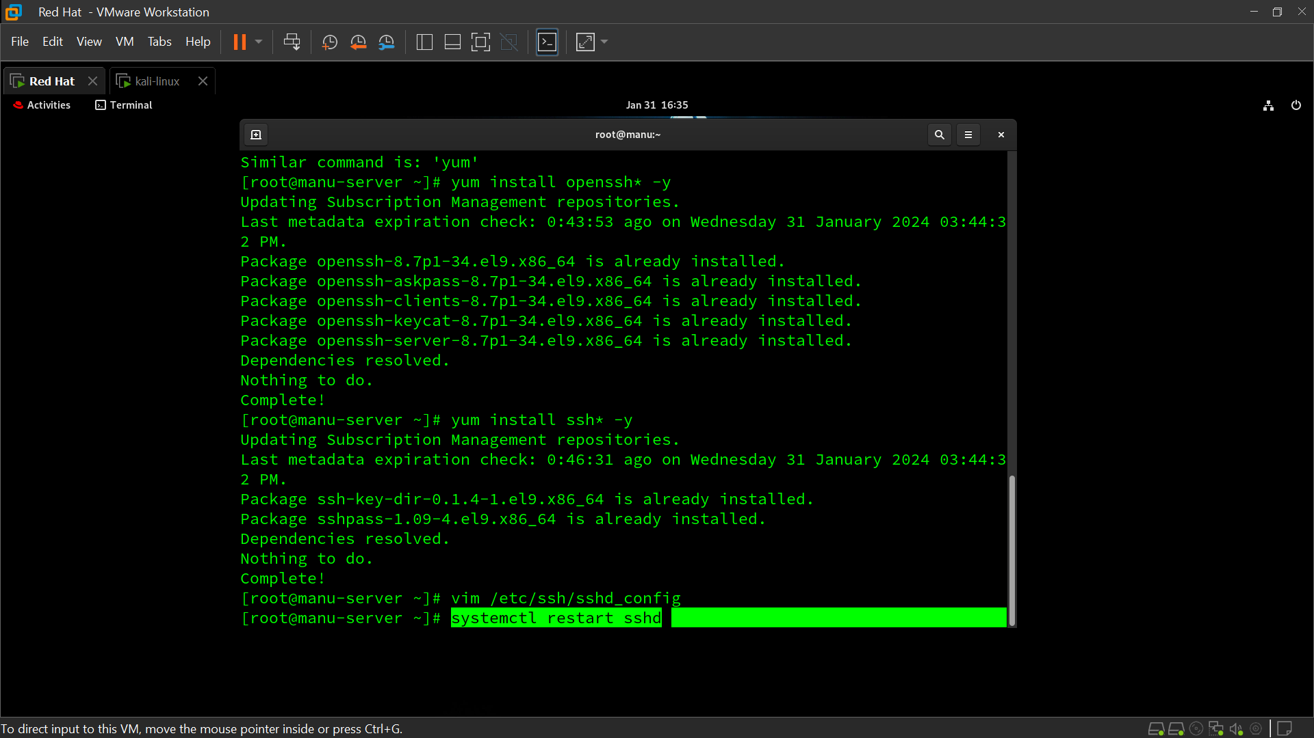

**STEP 7:-**

THEN GO TO THE CLIENT PC AND LOGIN FROM SSH AND PASSWORD

Ssh [root@192.168.220.136 (server](mailto:root@192.168.220.136%20(server) pc ip)

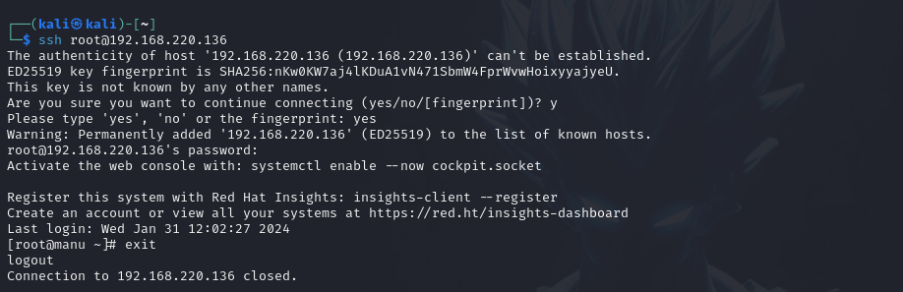

**STEP 8:-**

GENERATING INSCRIPTION KEY

ssh-keygen

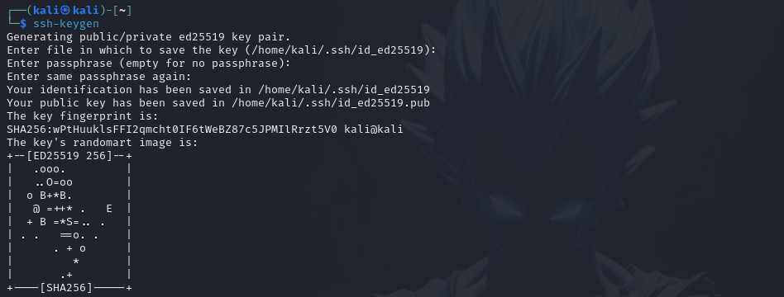

**STEP 9:-**

**COPY SSH ID**

ssh-copy-id root@192.168.220.136

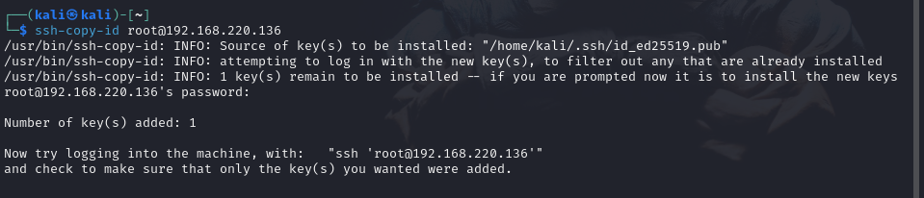

**STEP 10:-**

LOGIN FROM SSH THEN CONNECT WITHOUT PASSWD

ssh root@192.168.220.136

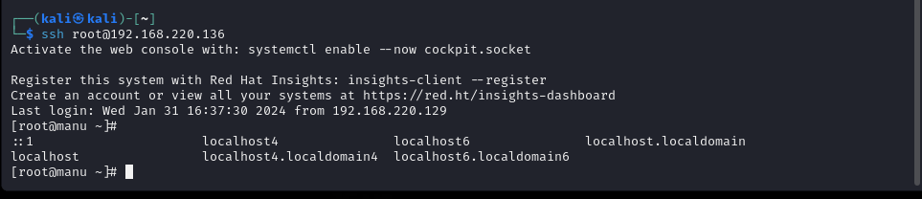

**STEP 11:-**

MAKE A FILE IN CLIENT PC AND THEN CHICK THE SERVER PC FILE IS MAKE OR NOT

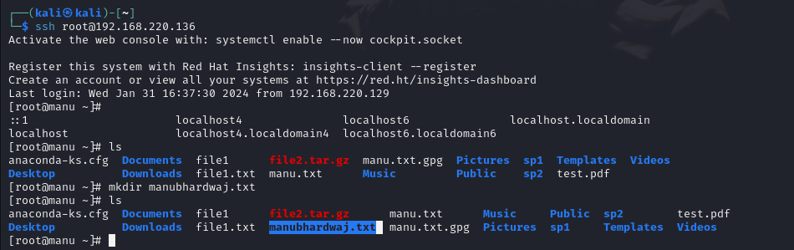

**STEP 12:-**

THIS IS SERVER PC WE CAN SE THIS FILE IS GENERATED

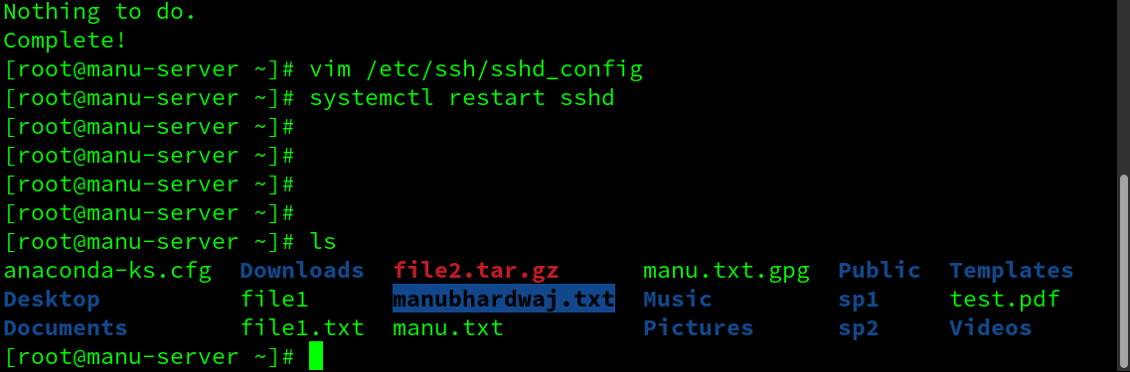

**STEP 13:-**

WE CAN CHECK THE LOG OF SSH INCIDENT

cd /var/log

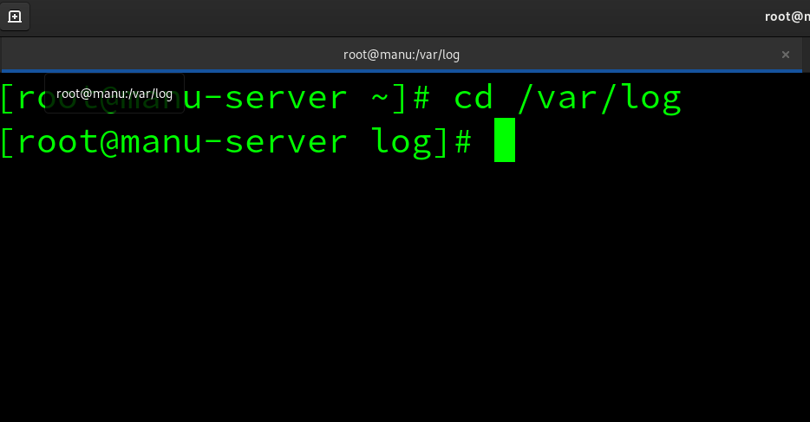

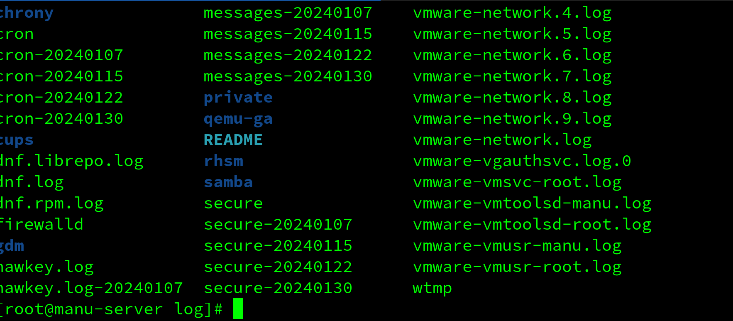

**STEP 14:-**

SEE THE LOGS OF SSH LOGIN

